Nada Tayem

Digital Composition Literature and Pedagogy

Dr. Kenneth Sherwood

Date: April 27th,2017

Digital Pedagogy Mini -project

Integrating Digital Tools and Digital Pedagogy

**Target Group:** University of Jordan - The English Department /Instructors and committee

**General Objective**: To generate digital pedagogy and introduce Wikis for the English department as a tool for collaborative planning and communication:

* Collaborative Planning tool: creating (syllabus, course/semester plan, research projects).
* Communicative tool: creating personal e-portfolios, hosting conferences).

**Time**: 1 hour

**Overview**

This project is addressed for those who have faith in digital pedagogy and tools and for anyone who is still skeptical about the digital pedagogy competence in enhancing teaching and learning experiences in the field of humanities. In this project, I suggest that by integrating digital pedagogy and employing wikis in universities among teachers who share the same field of interest, any course planning, curricula preparation, conference hosting, research project or any other sort of collaborative work will be more facilitated in the English department. The teaching experience will be more effective and powerful not only in relation to the classroom experience but even within the English department and the faculty members. Creating wikis means circulating knowledge in multiple directions.

Digital pedagogy is concerned about approaching different digital tools critically and wisely. In fact, incorporating electronic tools may seem for some people adapting digital pedagogy. But Digital pedagogy is way broader because it allows the development of critical processes that formulate professional teachers in their work as well as qualified learners. These digital approaches should empower both teachers and learners because they allow them to comfortably communicate learning with students inside the classroom as well as better invest their knowledge and experiences with their peers and in their institutions. By applying and using wikis, the faculty members will be able to contribute to their area of interest collaboratively and more broadly.

**Identifying Goals**

1. Highlighting the usefulness of the digital approach as critical and analytical tools. Instructors will benefit from the digital innovative approach not only in their teaching process but also in their field of research.
2. Introducing the characteristics of the Wikis as a useful tool that can facilitate planning and work proficiency as well as widening the teaching/learning scope, communication and research areas.

**Rationale**

Why is it important to implement digital pedagogy as exemplified by using wikis in the department and why is it important?

**Collaborative and Digital learning VS. Traditional learning**

Traditional learning environments are often characterized as being a method that is often self -centered and hierarchical. The one-way knowledge communication processes in which the teachers become the only source of knowledge is outdated, no more effective and proofs to be the least generative method for creative and critical thinking. In traditional learning teachers are ought to be responsible for assigning learning activities that are conducted by each student individually. Such process leads the use of the primary cognitive skills. It strips the teaching and learning process away from its real social dimension and this is totally in contrast with what distinguishes the digital method from traditional ways. Similarly, teachers within the same institute need to employ the same environment where knowledge flows collaboratively through multiple directions. Wikis work best when individual authorship is not important in comparison to the importance of results and outcomes. In this respect, it is important to note that the target of this paper is not diminishing teachers’ authorship on their own creativity but rather encouraging collaborative interaction and the use the highest cognitive skills for the sake of the over-all prosperity for everyone in the institution.

The benefits of applying wikis among teachers will positively target three major dimensions.

1. **Peers level**

Wikis saves the instructors' time and effort but more importantly, allow collaborative work. Teachers can virtually meet and work on planning together. Wikis are thus useful in knowledge managing. By using wikis, teachers will be able to share their teaching experience with other teachers. Instructors who are teaching the same course will be better able to share their teaching experiences with all other teachers. wikis allow working together in editing and preparing their course outlines and unlike blogs, for example, wikis can be edited by multiple permitted people and all conducted changes can be tracked in history page. Any recent edits show all changes made to the wiki. In addition to that, the body of the wiki can be content -based and not chronological based like blogs. This idea makes wiki more logical and appropriate especially when teachers aim to organize certain pages to serve a specific subject. For instance, all teachers who show interest in ecocriticism theory and topic can collaboratively work together to create a course plan, a syllabus texts, hyperlinks and researches within the same space.

Teachers still have the choice to keep or update the content of their works sequentially for different semesters and for the longer terms. In turn, such experience will positively reflect on the quality of education and the institution’s teaching reputation. When planning is collaborative, this indicates to more solidity and skillful level of organization and accordance. Wikis are of the best digital tool that promote collaborative work among teachers. Another collaborative works directed by wikis are joint research projects. They allow teachers to access to webs to contribute to the buildup of materials on these webs Furthermore, they can also offer the chance of creating small research projects discuss ideas together, collect information or articles regardless of their physical location.

1. **Benefits on Institutional Level**

Above and beyond, the institution will be able to communicate globally with other institutions. By using wikis one can propose that using digital pedagogy allow learning communication to go beyond the geographical spaces and can open more chances for e-learning and online education.

**C -Benefits for students:**

The method can increase the level of interaction between students and teachers as well as between students together.

**How to create a Wiki?**

Like any other websites that allow the creation of personal accounts, I created the Wiki on Workspaces with an email.

**Create a classroom**

After that, the site will ask to create a Wiki I created an imaginary class for 2021 which is only meant to demonstrate in steps the show how of creating a wiki. Once the wiki is successfully initiated, I was led to the Dashboard

On the Dashboard

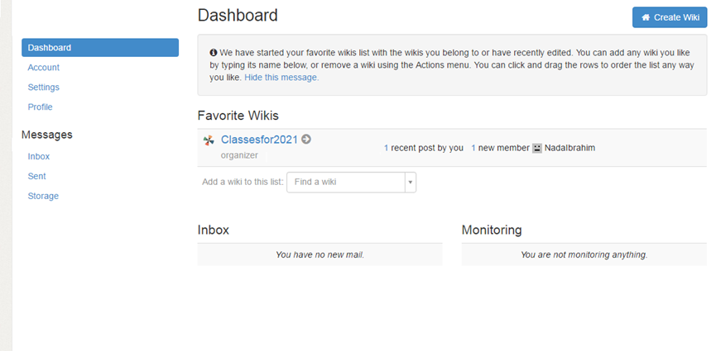

Image of the Dashboard

The second move is to add the students of the class so that they can access the Wiki.



There are two ways to invite members to the Wiki. The first is inviting students who have usernames, and the second is inviting students who do not have usernames and thus I have to create them their own usernames and passwords.

1.

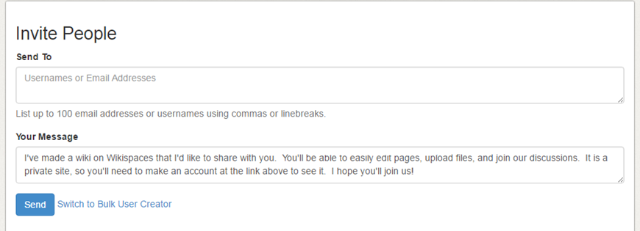

2.

To create users,

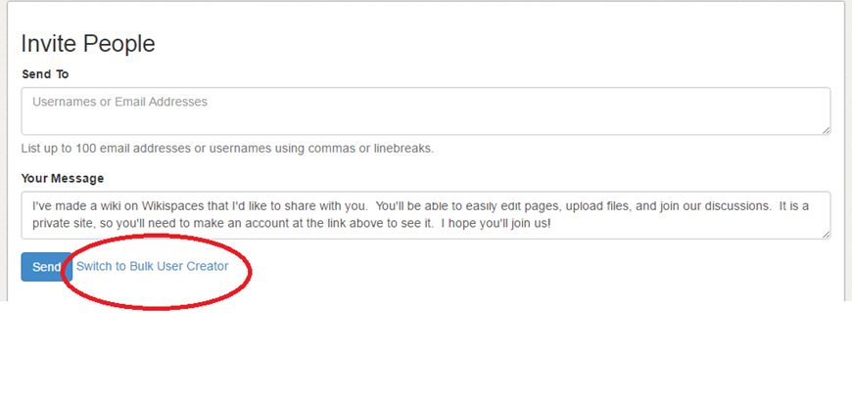

That will take you to the next page

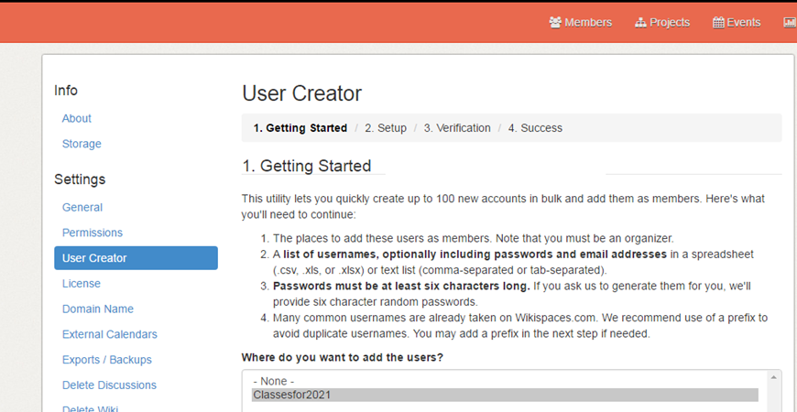

Following the instructions in the image above, I created three users and their passwords, which will be disseminated to them via email.

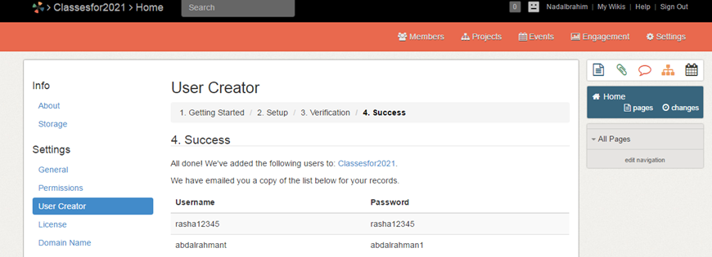

I also added one more user for the sake of creating projects… So there are three users, excluding me.

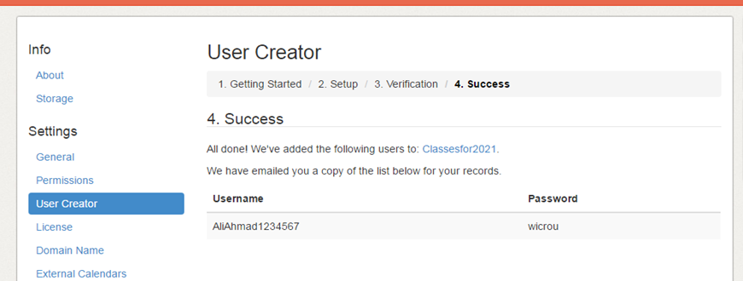

**Creation of Pages**

There are two ways to create pages on my Wiki, and both of them can be done from my "Home Page." I just clicked on the "Page" icon, circled in red below. A pop-up appeared asking for a page name, which I named it "Introduction to English Literature."

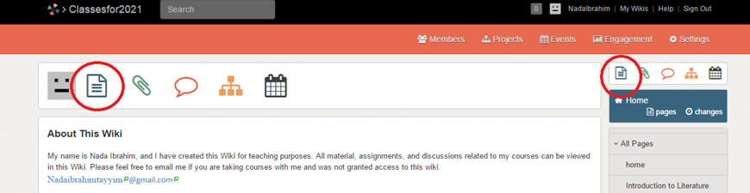

After the creation of the page, I used the edit bar, image shown below, to customize the page, add a brief introduction to the course for which I have created the page, and an image, and created a hyperlink to the syllabus, which I uploaded to pages and files using the attachment icon on the right of the page.

Wiki Page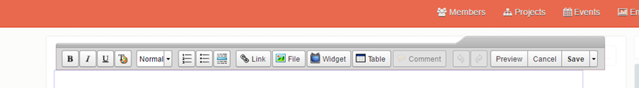

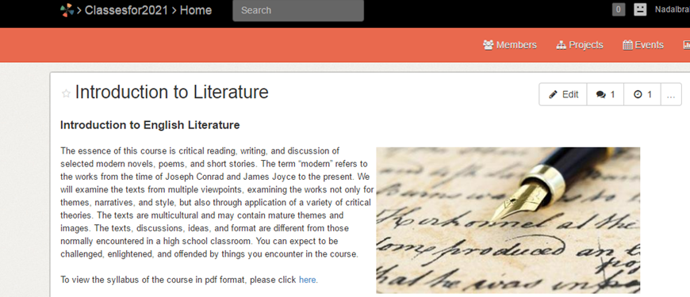

Moreover, I added a discussion to the page. Some of the functions here allow me to monitor who contributes and who doesn’t not. Now comes the "Customize" part. Go to settings and thin click on Look& Feel. This section will take to several options where you can change the colors of the wiki.